Scratch Advanced notes!

Coordinates and Shape animation!

## Week 1 – Advanced Coordinates and Shapes!

**Objectives!** This week we will look at using the PEN object to draw cool shapes and make cool patterns by playing with variables!

Stuff we will learn!

* The Pen Object in Scratch and how it is used to draw lines with Pen Up and Pen Down

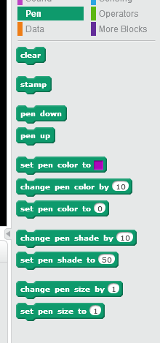

* Custom Blocks, and how they can make your code tidy!

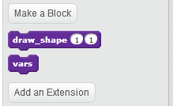

We will make a block that can draw a shape with any number of sides!

# Goals of this lesson

This week we will build a custom scratch block that can quickly draw a shape of any number of sides. We will then play with some cool effects by giving it different settings and watching what it can draw.

# Getting ready!

Just a quick reminder on your scratch-maths!

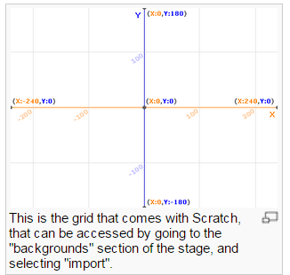

When building stuff in scratch, it can be very handy to use the background above and switch to something else when you are playing the game. We might not need it today, but might as well start using it!

You can set the X or Y position of any sprite using the “Motion” section of scratch.

If Y gets bigger, the sprite moves up!

If X gets bigger, the sprite moves right!

# Project 1: House Draw!

1. Start a new Scratch project
2. Set the background to the X-Y grid from the library
3. This is a lab exercise! Use the Pen object in Scratch to draw a house. Use the following blocks:
   1. Pen Down
   2. Pen Up
   3. Set Pen Color
   4. Set Pen
   5. Use Go To block to move the pen around and get the hang of X-Y!

Let’s see if you can do better than MY House!

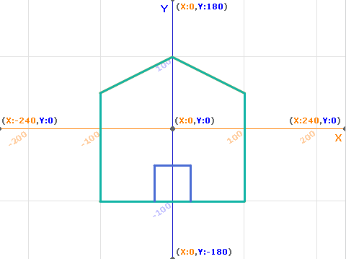

When you know the X,Y and the pen, it’s easy to draw shapes.

# Facts about Circles

Circles are all over the place in games!

It’s easy to draw square shapes, but how about circles?

There are a couple of things about circles you might remember from school (if you haven’t done it yet, don’t worry, it’s easy!!)

Here are some facts about circles!

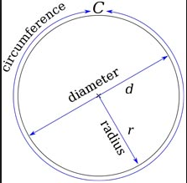

* Can you name all the lines in a circle?
  + The outside of a circle is called the “circumference”
  + The full width of a circle is called the “diameter”.
  + Half of the width of a circle is called the “radius” – we use this a lot!
* Angles:
  + There are 360 degrees in a full circle
    - How many in quarter of a circle?
    - How many in a third of a circle?

## Drawing a point on the edge of a circle

While it’s easy to figure out the X and Y of a square shape, it’s not so easy to find a point on a circle. However Scratch has some functions which make that easy – called Cos and Sin. If you have any angle, Cos(angle) will tell you the X for the sprite and Sin(angle) will tell you the Y. This only works if the circle has a radius of 1, but you can multiply by the radius to get the full angle.

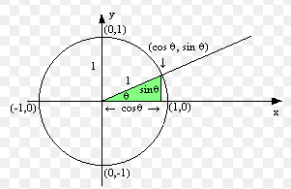

This might sound complicated, but it’s not really.. and it will make more sense when we get started!

This will tell you the Y coordinate a sprite would need to be at for a 9 degree angle.

# Project 2: Twister Part 1!

1. Create a new project called anything you like – I called mine “Twister”.
2. Add a background with 2 costumes – one all Black and the other the X-Y grid
3. Add a sprite that is a single “dot” – it doesn’t matter about the color
4. Add a custom block – the first version of the code is shown below, - you’ll need to add variables as needed and we will go through each line carefully!

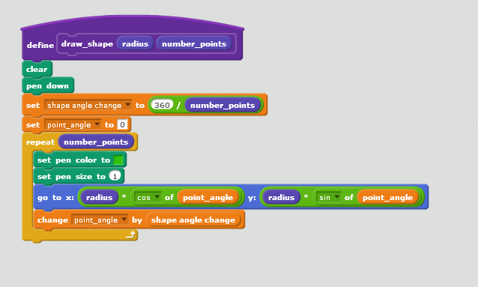

This block will draw a shape with a given number of points on a circle of a given radius size.

1. Run the code  
   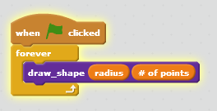
2. Set sliders on the variables and show them  
   